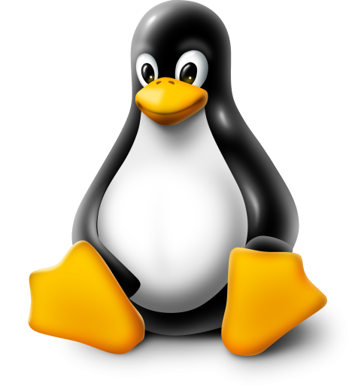
LINUX INTRODUCTION:
LINUX is an free and Open-source operating system.
OPERATING SYSTEM:
- An Operating System (OS) is software that acts as an interface between computer hardware components and the user.
- Every computer system must have at least one operating system to run other programs, Applications like Browsers.
MS Office, Notepad Games, etc., need some environment to run and perform its tasks.
- The OS helps you to communicate with the computer without knowing how to speak the computer's language. It is not possible
KERNAL: The kernel is the core of the system and manages the CPU, memory, and peripheral devices. The kernel is the lowest level of the OS.
DAEMONS: These are background services (printing, sound, scheduling, etc.) that either start up during boot or after you log into the desktop.
SHELL: is an environment in which we can run our commands, programs, and shell scripts. A Shell provides you with an interface to the Unix system. It gathers input from you and executes programs based on that input. When a program finishes executing, it displays that program's output.
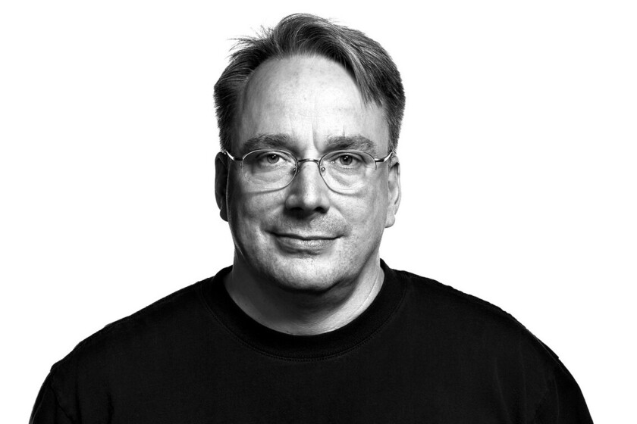
HISTORY:
- In 1991, Linus Torvalds a student at the University Of Helsinki, Finland, thought to have a freely available academic version of Unix started writing its own code.
- Later this project became the Linux kernel.
- The Linux kernel is written in C programming language.

- He wrote this program specially for his own PC as he wanted to use Unix 386 Intel computer but couldn't afford it.
- He did it on MINIX using GNU C compiler. GNU C compiler is still the main choice to compile Linux code but other compilers are also used like Intel C compiler.
- Firstly he wanted to name it as 'Freax’ but later it became 'Linux’
- In 1992, he released the kernel under GNU (General Public License).
- Today, supercomputers, smart phones, desktop, web servers, tablet, laptops and home appliances like washing machines. DVD players, routers, modems, cars, refrigerators, etc use Linux OS.

OPEN SOURCE:
Linux is also distributed under an open-source license. Open source follows these key tenants:
- The freedom to run the program, for any purpose.
- The freedom to study how the program works, and change it to make it do what you wish.
- The freedom to redistribute copies so you can help your neighbour.
- The freedom to distribute copies of your modified versions to others.
FLAVOURS / DISTRIBUTIONS:
 | It works like Mac OS and easy to use.
 | It works like windows and should be use by new comers.
 | It provides stability but not recommended to a new user.
 | If you want to use red hat and latest software.
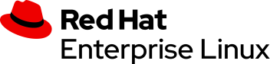 | To be used commercially.
 | If you want to use red hat but without its trademark.
 | It works same as Fedora but slightly older and more stable.
ARCHITECTURE: 